Bahria University,

Karachi Campus



COURSE: Computer Architecture and Logic Design

TERM: FALL 2022, CLASS: BSE- 3 (B)

PROJECT NAME

Digital Clock

Name:

Muhammad Shoaib Akhter Qadri 02-131212-009

Abdul Muqeet 02-131202-085

Muhammad Jahanzaib 02-131212-036

Muhammad Nouman Afzal 02-131202-045

Engr.Dr.Sorath Hansrajani/ Engr. Ramsha Mashood

Signed Remarks: Score:

**Table Of Content**

**Topic Page No**

1. Introduction & Problem 3
2. Component 3
3. Functionality 3
4. Specification 4
5. Circuit Diagram 4
6. Working Steps 6
7. Conclusion 6

* **Introduction & Problem:**

Digital Clock is one of the most popular project. In this project, the main objective of the this project is **to watch time and set time according to user’s requirement**.

In this project, We can watch the time easily as well as we can set time on here.

The problem is that except watching time and set time, we cannot do anything more.

* **Component:**

We used **JK Flips-Flop** for this **Digital Clock** project.

* **Functionalities:**

Digital Clock project is one of the complex project. In this project, we can easily watch time and the time is show in digits from 0-9. In this project, we can set time according to our needs and requirement and after set the time, the clock is again start and show time. In this project , the digital clock show 24 hours for time.

* **Specification:**
* 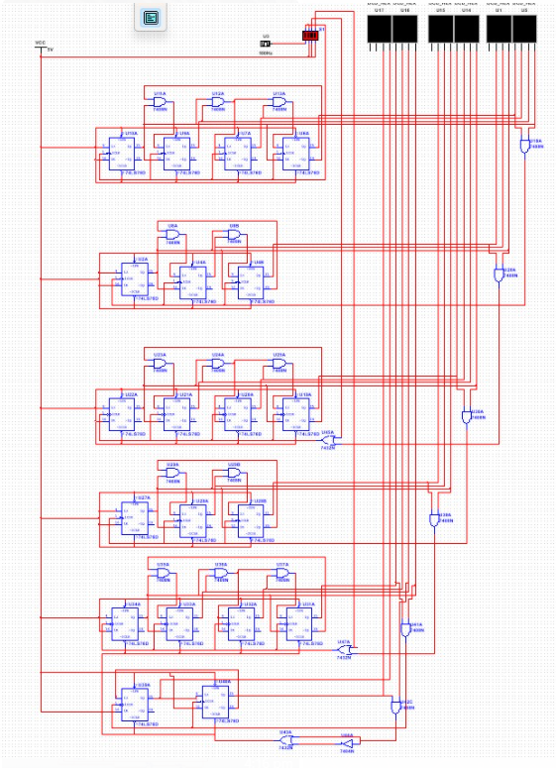**Circuit Diagram:**

* **Working Steps:**
* We use
* **Conclusion**

While the final version resulted in this Digital Clock project that it shows best time system in digits as well as it has ability to set time system and after that the time is start from there again. In this Digital Clock project, **the user watch time easily**.